FRA 2020 Remote Sensing Survey and the way forward
Background paper 5
for discussion at the FRA 2025 Online Expert consultation

Contents
FRA 2020 Remote Sensing Survey and the way forward 1
Introduction 2
1. What was done in FRA 2020 RS? 2
Tessellation and sampling units 2
Data collection 3
Stratification & sample allocation 4
Accuracy assessment 5
2. Review of the FRA 2020 RSS approach and recommendations for 2024 RSS 5
Tesselation and sampling units 5
Sample allocation 7
Accuracy assessment 7
3. Recommendations and prospects for FRA 2025 RSS 7
Tessellation and sampling units 7
Stratification 7
Sample allocation 9
Classification Schema 13
References 13

Introduction
The FAO Office of the Chief Statistician recommended the Global Forest Resources Assessment (FRA) to develop “independent FAO estimates of national forest cover based on Earth Observation data to be used to validate national submissions”. Following these recommendations, FRA, in collaboration with partners has developed a remote sensing component that focuses on three aspects: production of comprehensive and consistent global statistics on forest area and its changes, development of country capacity to use remote sensing for forest monitoring and assessment as well as production of an independent global and regional estimates on forest land use and its changes. For FRA 2020, these objectives were achieved through a series of capacity development workshops, and the implementation of the FRA 2020 Remote Sensing Survey (RSS).
The key results of the FRA 2020 Remote Sensing Survey were released in November 2021, at the 26th UN Climate Change Conference of the Parties (COP 26) and the complete FRA RSS 200 report was released (https://www.fao.org/3/cb9970en/cb9970en.pdf ) in May 2022, during the XV World Forestry Congress in Seoul.
The strengths and challenges of the FRA 2020 RSS approach were both inherent in the use of a remote sensing-based methodology, combined with the participation of a global network of experts with local field knowledge along with the use of an online tool for visual photointerpretation. Also, the RSS, contrary to the main FRA report, provides estimates at global, regional and ecozone levels. To shape the next FRA RSS, imitations and possible improvements of the FRA 2020 RSS needs to be addressed, regarding in particular the production of spatial explicit outputs, annual/more regular updates, and adding information on forest condition (i.e. degradation or recovery).
The recent and rapid development of affordable cloud-based solutions for storing, accessing and analyzing remote sensing data and products has drastically facilitated remote sensing based assessments even in developing countries with low technical capacity and computing infrastructure. These technical innovations can play an important role in improving national, regional and global databases on forest and land resources and their changes and facilitate monitoring progress towards several SDGs.
This background paper presents a summary of the methodology of the FRA 2020 RSS and, building on lessons learned from FRA 2020 RSS and technological and partnership opportunities, suggest potential areas of improvement for the next cycle of the FRA RSS for review and feedback of the participants of the 2022 FRA Expert Consultation.

1. What was done in FRA 2020 RS?

Tessellation and sampling units
Following good practice recommendations from scientific literature (Olofsson et al., 2014), estimates of forest land use area changes for the FRA 2020 RSS were obtained from a sample-based approach.
Sample data was collected following a stratified random sampling design. The Earth’s surface was divided into equal area hexagons (39.62 ha each), originating from a discrete global grid of equally sized hexagons. This produced more than 1.2*10⁹ hexagons, treated as sample units to which cover estimates were attached, out of which approximately 335 million fell on land and constituted our sampling frame. An additional cover assessment was carried out for a 1 ha square sample unit located at the centroid of each hexagon to collect more detailed information on land use and tree cover, land-use change and related drivers (Figure 1).
Figure 1. Hexagonal tessellation of the Earth, based on a truncated icosahedron and single hexagon plot with 1-hectare square centroid
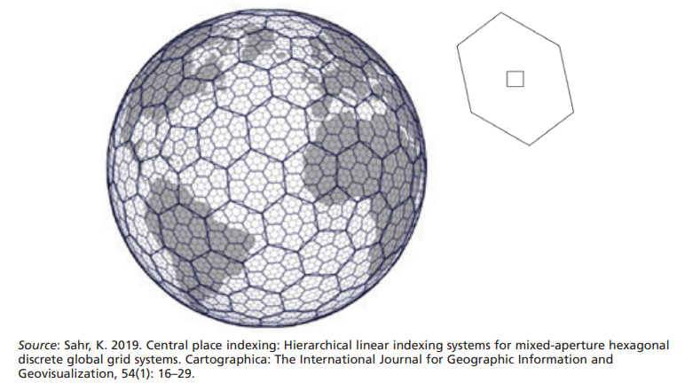

Data collection
Data for each sampling unit was collected using visual interpretation and Open Foris Collect Earth Online (CEO) (Saah et al., 2019). CEO is a custom-built, free, open-source and user-friendly software that enables the visualization and interpretation of satellite imagery in a cloud-based environment. The analysis was conducted using Landsat and Sentinel images as main data sources. Best available Landsat 5 or Landsat 7 data were used for years 2000 and 2010, and best available Landsat 8 and Sentinel-2 for 2018. VHR images from Bing Maps, DigitalGlobe and MapBox were also available as additional data to support the analysis. In addition, CEO has the option to overlay each plot as a Keyhole Markup Language file for use in on Google Earth desktop software.
The following variables were collected for each sampling unit.
- Hexagon centroid: Discrete land use class and sub-class for 2018, as defined by the FRA, as well as land-use change classes for the given time intervals (2000–2010 and 2010–2018). The land-use and land-use change classes were assigned according to the majority (i.e. if more than half of the centroid is covered by forest, it will be classified as Forest). The presence of trees was also recorded for the “Other Land” subcategory, to extract the percentage and hectares of other land with tree cover (See Figure 3).
- Hexagon: Quantitative estimation of the proportion of the area of the hexagon falling into each main land-use class (Forest, Other Wooded Land, Other Land and Water) in 2018. Forest gains and losses were recorded for 2000–2010 and 2010–2018. In both classifications, discrete 10 percent classes were used (see Figure 3).

At both levels (centroid and hexagon), the land-use type was recorded for 2018. Land-use changes for periods 2000–2010 and 2010–2018 were recorded using the following classes: 1) Stable forest; 2) Stable non forest; 3) Forest loss; 4) Forest gain.
Figure 2 Variables collected for both the centroid and the full hexagon.
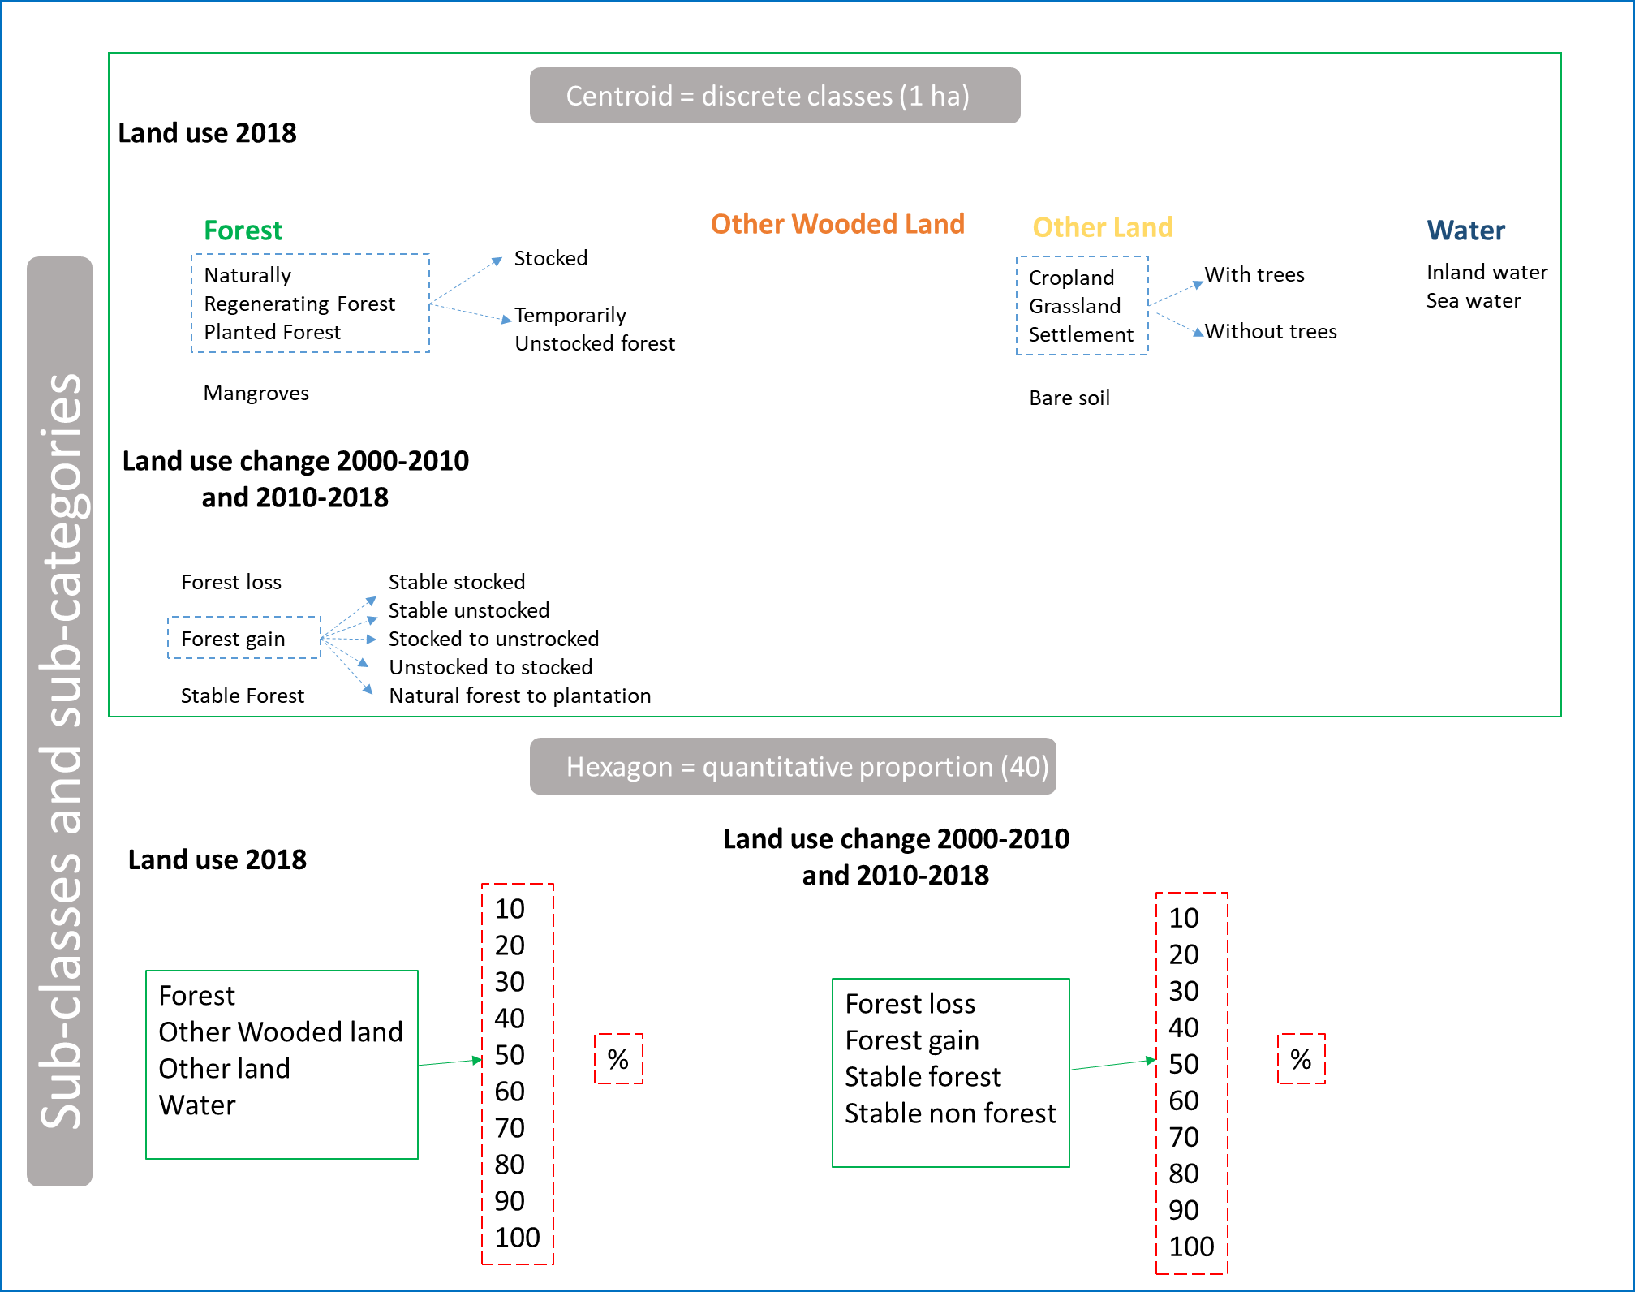

Stratification & sample allocation
The full population of hexagons was stratified to 80 strata, using a combination of the 20 Global Ecological Zones (GEZ) and four strata of tree cover change between 2000 and 2018 from the Global Forest Change product (FAO, 2010; Hansen et al., 2013). These four strata consisted of:
- big changes: > 40 percent of pixels in the hexagon with changes;
- small changes: between 5 and 40 percent of pixels in the hexagon with changes;
- no changes in tree-covered areas (no change forest): < 5 percent of pixels with changes and > 10 percent tree cover; and
- no changes outside tree-covered areas (no change non-forest): < 5 percent of pixels with changes and < 10 percent tree cover.

After defining the strata, the sample allocation was carried out in four stages:

- Allocating 50 percent to the two ‘no changes’ Hansen strata and 50 percent to the two ‘changes’ strata.
- The sample in the ‘no changes’ strata is equally divided between ‘no change forest’ and ‘no change non- forest’, i.e. 100 000 units to each stratum.
- The sample in the ‘changes’ strata is divided between ‘big changes’ (140 000 units) and ‘small changes’ (60 000 units).

The final number of samples for each 80 strata was calculated using proportional sampling and the samples to be assessed were chosen randomly.
The final distribution of the Remote Sensing Survey samples (400 000 units) is shown in Figure 2. The sample distribution pattern reflects land cover change dynamics in different areas. For example, in the central part of Chile, the high concentration of samples is related to forest management and plantation cycles, while in the north of Paraguay it is related more to deforestation and land-use changes than land cover changes.
Figure 3 FRA 2020 RSS Samples distribution by climatic domain
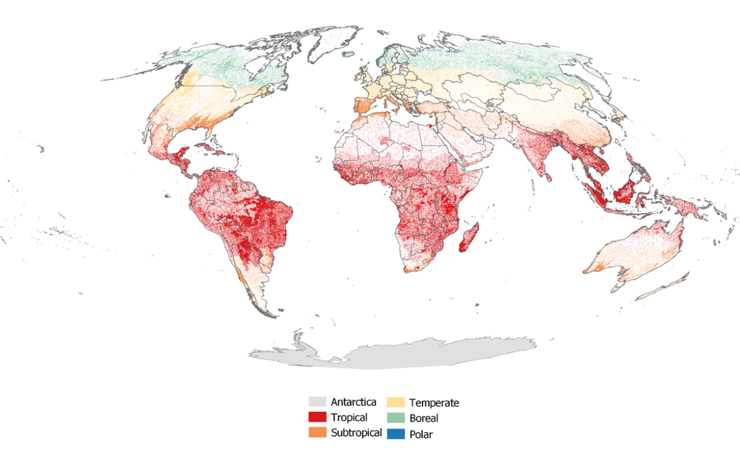

Accuracy assessment
An interpretation accuracy assessment was conducted at the end of the FRA 2020 Remote Sensing Survey data collection. The assessment was done for approximately 3 percent (about 12 000 units) of the global sample sites. Each unit of the supervised sample was photo-interpreted by three independent operators. Operators were assigned to the regions corresponding to their specific expertise.

2. Review of the FRA 2020 RSS approach and recommendations for 2024 RSS

Tesselation and sampling units
The efficiency of the sampling units (see section 2.1) to collect the data variables used in the FRA 2020 RSS (see section 2.2) was assessed by calculating the ratio between the variance of the centroid and the hexagon (Gallego, 2012). This measurement gives the idea of accuracy of the estimator. For instance, the efficiency of sampling unit of forest loss between the years 2010 and 2018 was 2.25, meaning that the hexagon sample unit was 2.25 more efficient to estimate this variable than the centroid.

Table 1 reports such efficiency for forest area estimation in 2018 and for forest changes (gain and loss) in the time intervals considered.
Table 1 Relative efficiency (overall by subregion) of the full hexagons compared to centroid observations for the estimation of forest area and major changes.
 | Forest area 2018 | Forest  gain 2000–2010 | Forest loss 2000–2010 | Forest  gain 2010–2018 | Forest  loss 2010–2018
Caribbean | 1.37 | 3.18 | NR | 2.30 | 10.03
Central America | 1.71 | 2.24 | 0.82 | 2.60 | 4.19
Eastern and Southern Africa | 1.34 | 0.91 | 1.37 | 2.47 | 2.77
East Asia | 1.96 | 1.39 | 2.50 | 1.57 | 4.63
Europe (Including Russia) | 1.55 | 2.27 | 4.01 | 2.54 | 3.51
North Africa | 1.38 | 10.55 | 7.43 | 1.03 | 4.28
North America | 1.81 | 0.16 | 2.03 | 0.66 | 1.83
Oceania | 1.26 | 0.70 | 2.00 | 1.21 | 7.81
South America | 1.51 | 2.13 | 2.21 | 2.05 | 2.25
South and Southeast Asia | 1.30 | 1.63 | 2.28 | 2.65 | 2.22
Western and Central Africa | 1.29 | 1.75 | 2.44 | 2.94 | 2.32
Western and Central Asia | 1.80 | 0.89 | 7.24 | 8.99 | 5.68
Total | 1.54 | 1.78 | 2.21 | 2.04 | 2.76

The efficiency values obtained strongly suggest that estimations from the full hexagons are generally more reliable.
The quantitative photo-interpretation observations on the hexagons have proved to provide more accurate estimates, with a relative efficiency of around 1.5 for forest area estimation and between 2 and 3 for forest changes, although the relative efficiency strongly depends on the heterogeneity of the landscape or the spatial pattern of changes: if the landscape or the pattern of changes is composed of large homogeneous units, large sampling units bring limited benefits. In exchange, the relative efficiency of large units is larger for patterns composed of small, speckled units. This is probably the reason why large sample units (hexagons in this case) have a higher relative efficiency to estimate changes than forest area at a given date. However, there are still some issues to consider:
- The hexagon observations were only conducted for the main variables (e.g. forest area 2018, forest loss, forest change), but not for other variables, such as IPCC classes, deforestation drivers, etc. This obliged to carry out a benchmarking step to improve the consistency of results.
- The cost of large units may be significantly correlated with the heterogeneity of spatial patterns, and therefore would be also correlated with the relative efficiency of large units.
- The increase of effort of photo-interpreters by including the quantitative photo-interpretation observations on the hexagons has not been quantified. Asking photo-interpreters to record the time dedicated to assessing the centroid versus the time dedicated to attributing a quantitative value in the hexagon would result in an increase in the photo-interpreter’s workload. The most frequent feedback from photo-interpreters is that the longest task is understanding the context of the sample unit. This might need to be more systematically confirmed. For the moment, it strongly suggests that semicontinuous data on relatively large units (e.g. 40 ha) are more efficient than 0– 1 observations on a small “centroid”.

Sample allocation
The sample allocation derived from the 6-country pilot study done in 2017, and later used to define the sample allocation of the FRA 202 RSS resulted in a non-optimal sample allocation, as we will see in the comparison of the optimal sample allocation. Too many samples in the strata big change, and missing samples in the other strata.One of the most usual approaches to optimal sample allocation is the Neyman criterion (Cochran, 1977), which requires choosing a priority variable to tune the sample size in each stratum.
The choice of the priority variable has a degree of subjectivity. The initial proposal is “net forest loss” (forest loss minus forest gain), considering that change detection was the most important goal of this exercise.

Accuracy assessment
This analysis was done to include the interpreter subjectivity in the confidence interval. The method still needs to be validated by the scientific community, but some general conclusions can be anticipated:
- The uncertainty of the estimations, both for forest area and its changes, is likely to increase by a large factor.
Table 2 Sampling error and total error of the main variables
 | Mha | Confidence interval (only sampling error) | Enlarged confidence interval including interpreter subjectivity
Forest 2018 | 3969 | ±0.37% | ±2.7%
Forest loss 2000– 2018 | 173 | ±1.6% | ±5.2%

3. Recommendations and prospects for FRA 2025 RSS

Tessellation and sampling units
Considering the results presented in table 1, and the expanded results we obtained from the combination of hexagons and centroids, we recommended keeping the hexagon for key area estimates and the centroids to collect more detailed thematic data.
The global tessellation approach applied in FRA 2020 RSS demonstrated to be enough flexible to incorporate new layers of information for further strata definition, select complementary samples and implement additional studies, such as a special study focusing on mangrove forests.
Considering the advantages of keeping the sampling frame and the sample as constant as possible, we conclude that there is no need of changing the sampling frame for the FRA 2025 RSS.

Stratification
The stratification based on the Hansen Global Forest Cover products was good enough for the key variables. The experience gained in FRA2020-RSS suggests a few possible improvements. In particular, the number of EO-based forest mapping products is increasing, so that additional information can be introduced in the stratification. Criteria to choose layers to be combined for an improved stratification mayinclude:
- Reducing the number of samples in stable strata by a combination of auxiliary data.
- Increasing the precision of forest area gain detection with auxiliary remote sensing products.
The strata labels used for FRA2020-RSS can be kept with one substantial modification: The “stable non-forest” stratum can be split, separating areas for which the complete absence of forest is very reliable. Such areas would define an area for reduced intensity sampling or excluded stratum.
Let us assume that we have a considerable part of the tessellation hexagons in the sampling frame for which all available land cover maps coincide that there is no forest at all in the whole timespan 2000–2022. We can decide to reduce sampling intensity in such areas in the sampling process by defining an excluded stratum.
Potential source of auxiliary data to adjust the stratification:
- ESA World Cover 2020:
Sentinel 2 and Sentinel 1 base land cover with 10 classes for the year 2020. Pixel size of 10 m. The FnF layer was produced defining “Tree cover” as “Lands covered with trees, with vegetation cover over 30%”.
Built-up, Bare/sparse vegetation, Snow and Ice, Moss and lichen and permanent water bodies with low probability of tree cover.

- ESRI 2020:
Sentinel 2 and Sentinel 1 base land cover with 10 classes for the year 2020. Pixel size of 10 m. The FnF layer was produced defining “Trees” as “Any significant clustering of tall (~15 feet or higher) dense vegetation, typically with a closed or dense canopy; examples: wooded vegetation, clusters of dense tall vegetation within savannas, plantations, swamps or mangroves (dense/tall vegetation with ephemeral water or canopy too thick to detect water underneath)”.
Built Area, Bare ground, Snow/Ice, Water and ice could be used to identify area with low probability of tree cover.
- GlobeLand30:
Landsat-TM base land cover with 10 classes for years 2000, 2010 and 2020 within a four-year period. Besides multispectral images, other auxiliary data are included in the processing (http://glc30.tianditu.com). The FnF layer was produced defining “Forest” as “Lands covered with trees, with vegetation cover over 30%, including deciduous and coniferous forests and sparse woodland with cover 10–30%”.
Artificial Surface, bare land and permanent snow and ice and water bodies and ice could be used to identify area with low probability of tree cover..

Keeping the sample as stable as possible with an updated stratification
The thresholds to define “large change”, “small change” and “no change” are currently set at 40% and 5% in Hansen-GFC.
In any case, even if the strata labels are kept unchanged, the stratification will change because the reference time interval changes and new land cover maps will be probably integrated. If we maximize the stability of the sample of hexagons with an updated stratification, we face a problem with the computation of estimators and their variances: we will have in the same updated stratum sample elements that come from different old strata, and therefore have been sampled with different probabilities. We can think of different options to deal with this situation:
- Moving from the simple estimators we have used in FRA 2020-RSS to the Horvitz-Thomson (HT) estimators for unequal probability sampling. The problem with the HT estimators is that the variance computation requires the joint probability for each pair of sample elements. If we consider the overall sample, this will lead to a matrix of $16×{10}^{10}$ joint probabilities. The number can be reduced by taking into account that the matrix is symmetric and that we can treat separately each subregion and GEZ, but it remains a considerable problem.
- Considering the intersection of old strata $h$ and updated strata $h'$ as post-strata. This is the easiest way to deal with the issue, but anomalies can appear in small intersections with little or no sample. The aggregated size of such small intersections can be assessed.
- Adjusting (complementing or subsampling) sample elements that had been sampled with a probability different from the probability corresponding to the updated stratum in which they fall. This is also feasible, but external observers might have problems understanding the process.

Sample allocation
Regarding the optimal Neyman allocation based on the FRA 2020 RSS results, there are different options to improve sampling allocation in future cycles. We simulate the optimal sample allocation for two scenarios. The first is collecting 200 000 additional samples and the second is adding 400 000 samples.

Scenario 1 of reduction to 200 000 units
We assume:
- The next FRA-RSS moves from the current sample of ca. 400 000 units photo-interpreted by one operator and 12 000 interpreted by three supervisors (or only two in some cases) to a scheme based on approximately 200 000 units interpreted by two operators. This assumption is realistic in view of the lessons learnt in FRA 2020 –RSS.
- We keep the same FRA 2020 RSS stratification. We should expect to have a better stratification for the next round, but we need the assumption to compute a hypothetical allocation and make a description of its behaviour.
- For this exercise we have split three subregions:
  - North America has been split into Mexico and “Northern North America”
  - Europe has been split into Russia and “the rest”
  - Oceania has been split into Australia and “the rest”
- We want to keep the sample as stable as possible to save effort and cost by reusing the photointerpretation made for FRA 2020 –RSS.
We apply a slightly modified version of a Neyman allocation using the estimated “Forest loss in 2000-2018” as target variable on what we have called a cross-stratum, i.e.
$$Cross stratum rgh=Subregion r ∩GEZ g ∩Hansen stratum h$$
The modification applied to the straightforward Neyman allocation consists of adding some sample elements for strata on which FRA 2020 has not found any forest loss, but forest was present in 2018.
The modified Neyman allocation can be aggregated by subregions, GEZ or Hansen strata. 3, Table 4 and Table 5 give some indications on the allocation changes suggested for a Neyman-optimized sample using forest loss as a priority variable, even if the allocation should be reviewed when an improved stratification is defined. When we look at these tables, we should consider that the total Neyman-optimized sample refers to a total of ca. 200 000 units instead of the 400 000 units of the current sample. Therefore when $2m_{***}≈n_{***}$ , the sampling rate in the corresponding area remains roughly constant.
North America (including Mexico), Europe, Russia and Australia would strongly reduce the sampling rate, while Western and Central Africa and Central America would increase the sample. South America would also increase the sampling rate in some areas.
Most tropical GEZ have a slight decrease in the sample size in number, which means a substantial increase in the share of tropical areas in the adjusted sample. Tropical forest (rainforest, moist forest and dry forest together), would account for 67% of the optimized sample, versus 44% in the current sample allocation. This means a substantial sample reduction in most of the other GEZ.
An apparently surprising fact is that the stratum “(strong) change” would reduce its share from 38.6% to 13.4% in the optimized sample. In exchange, the “small change forest” would increase its share from 10.7% to 27.3%. The main reason for this allocation change is that the “(strong) change” is rather small (2.6% of the sampling frame) versus 8.3% of the “small change forest” stratum. The variability per unit of forest loss per unit is similar for both strata, which means that the contribution to the overall variance of forest loss is much larger for the “small change forest” stratum with the current sample allocation even if the forest loss area is similar in both strata (Table 5).
Table 3 Preliminary allocation of a Neyman-optimized sample, scenario 200 k. Aggregation per groups of countries
 | $$n_{r}$$ | $m_{r}$ | Stable sample | New sample
North America North | 61318 | 14019 | 12456 | 1563
Mexico | 7933 | 2804 | 2732 | 72
Central America | 3139 | 4793 | 1820 | 2973
Caribbean | 1141 | 498 | 419 | 79
South America | 92509 | 56770 | 43635 | 13135
Russia | 38750 | 10505 | 9443 | 1062
Europe other | 22126 | 3697 | 3694 | 3
North Africa | 10705 | 3585 | 2792 | 793
Western and Central Africa | 26806 | 29432 | 17936 | 11496
Eastern and Southern Africa | 42098 | 29108 | 20128 | 8980
Western and Central Asia | 10732 | 3664 | 2254 | 1410
East Asia | 16477 | 8394 | 7054 | 1340
South and Southeast Asia | 48104 | 28300 | 21141 | 7159
Australia | 16605 | 3696 | 3545 | 151
Oceania other | 2598 | 872 | 830 | 42
Total | 401041 | 200137 | 149879 | 50258

Table 4 Preliminary allocation of a Neyman-optimized sample, scenario 200 k. Aggregation per environmental zones
GEZ | $$n_{g}$$ | $m_{g}$ | Stable sample | New sample
Tropical rainforest | 80471 | 55747 | 39168 | 16579
Tropical moist forest | 53144 | 48015 | 31260 | 16755
Tropical dry forest | 42024 | 30435 | 22813 | 7622
Tropical shrubland | 23031 | 6693 | 5907 | 786
Tropical desert | 6765 | 244 | 244 | 0
Tropical mountain system | 15065 | 8258 | 7154 | 1104
Subtropical humid forest | 17182 | 8899 | 6634 | 2265
Subtropical dry forest | 18060 | 2173 | 2173 | 0
Subtropical steppe | 10172 | 3471 | 2633 | 838
Subtropical desert | 9309 | 2741 | 2590 | 151
Subtropical mountain system | 10824 | 3943 | 3306 | 637
Temperate oceanic forest | 7338 | 892 | 892 | 0
Temperate continental forest | 15213 | 5663 | 5506 | 157
Temperate steppe | 7958 | 4478 | 2193 | 2285
Temperate desert | 8864 | 573 | 573 | 0
Temperate mountain system | 21466 | 4397 | 4345 | 52
Boreal coniferous forest | 20054 | 7034 | 6007 | 1027
Boreal tundra woodland | 12553 | 2530 | 2530 | 0
Boreal mountain system | 19139 | 3635 | 3635 | 0
Polar | 2409 | 316 | 316 | 0
Total | 401041 | 200137 | 149879 | 50258

Table 5 Preliminary allocation of a Neyman-optimized sample, scenario 200 k. Aggregation per Hansen-GFC strata
Stratum | $$n_{h}$$ | $m_{h}$ | Stable sample | New sample
Change | 154581 | 26805 | 26805 | 0
Small change | 42940 | 54573 | 34985 | 19588
No forest stable | 89324 | 38650 | 31003 | 7647
Forest stable | 114196 | 80109 | 57086 | 23023
Total | 401041 | 200137 | 149879 | 50258

Table 6 Contribution of each Hansen-GFC stratum to the forest loss area and to the variance of its estimation with the current FRA2020-FSS sample allocation in scenario 200 k.
 | Area |  | Variance of | estimates
Stratum | Forest loss 2000_10 | Forest loss 2010_18 | Forest loss 2000_10 | Forest loss 2010_18
Change | 35.8% | 35.8% | 2.9% | 3.5%
Small change | 38.8% | 40.0% | 33.7% | 35.7%
No forest stable | 6.1% | 5.0% | 19.0% | 16.9%
Forest stable | 19.4% | 19.2% | 44.4% | 43.8%

Scenario 2: keeping the sample size of 400,000 units
Same splitting of subregions and minimum sample size per cross-strata.

Table 7 Preliminary allocation of a Neyman-optimized sample, scenario 400 k. Aggregation per groups of countries
Region | FRA2020 RSS sample | N Neyman  400k | Stable sample 400k | New sample 400k
North America North | 61318 | 28046 | 20277 | 7769
Mexico | 7933 | 5591 | 4179 | 1412
Central America | 3139 | 9645 | 2235 | 7410
Caribbean | 1141 | 946 | 564 | 382
South America | 92509 | 114044 | 58090 | 55954
Russia | 38750 | 20983 | 16499 | 4484
Europe other | 22126 | 7210 | 7132 | 78
North Africa | 10705 | 6963 | 3575 | 3388
Western and Central Africa | 26806 | 59164 | 21946 | 37218
Eastern and Southern Africa | 42098 | 58312 | 24789 | 33523
Western and Central Asia | 10732 | 7056 | 3358 | 3698
East Asia | 16477 | 16666 | 10902 | 5764
South and Southeast Asia | 48104 | 56787 | 31582 | 25205
Australia | 16605 | 6954 | 4388 | 2566
Oceania other | 2598 | 1630 | 1326 | 304
World | 401041 | 399997 | 210842 | 189155

Table 8 Preliminary allocation of a Neyman-optimized sample, scenario 400 k. Aggregation per environmental zones
Number  GEZ | GEZ | SN  samples | SN_ Neyman  400k | SStable sample 400k | SNew sample 400k
11 | Tropical rainforest | 80471 | 112015 | 54091 | 57924
12 | Tropical moist forest | 53144 | 96507 | 39367 | 57140
13 | Tropical dry forest | 42024 | 61121 | 27825 | 33296
14 | Tropical shrubland | 23031 | 13399 | 9565 | 3834
15 | Tropical desert | 6765 | 231 | 231 | 0
16 | Tropical mountain system | 15065 | 16488 | 10457 | 6031
21 | Subtropical humid forest | 17182 | 17715 | 8999 | 8716
22 | Subtropical dry forest | 18060 | 4134 | 4134 | 0
23 | Subtropical steppe | 10172 | 6813 | 3513 | 3300
24 | Subtropical desert | 9309 | 5466 | 3034 | 2432
25 | Subtropical mountain system | 10824 | 7813 | 5568 | 2245
31 | Temperate oceanic forest | 7338 | 1703 | 1645 | 58
32 | Temperate continental forest | 15213 | 11300 | 9536 | 1764
33 | Temperate steppe | 7958 | 8763 | 2983 | 5780
34 | Temperate desert | 8864 | 1056 | 1056 | 0
35 | Temperate mountain system | 21466 | 8568 | 8196 | 372
41 | Boreal coniferous forest | 20054 | 14107 | 9277 | 4830
42 | Boreal tundra woodland | 12553 | 5027 | 4287 | 740
43 | Boreal mountain system | 19139 | 7171 | 6478 | 693
50 | Polar | 2409 | 600 | 600 | 0
Total | World | 401041 | 399997 | 210842 | 189155

Table 9 Contribution of each Hansen-GFC stratum to the forest loss area and to the variance of its estimation with the current FRA2020-FSS sample allocation and new sample allocation in scenario 400
Strata |  | N samples | N_  Neyman  400k | Stable sample 400k | New sample 400k
1 | Change | 154581 | 53695 | 53695 | 0
2 | Small change | 42940 | 109574 | 38822 | 70752
3 | No forest stable | 89324 | 76448 | 45029 | 31419
4 | Forest stable | 114196 | 160280 | 73296 | 86984
 | Total | 401041 | 399997 | 210842 | 189155

Classification Schema
Regarding the FRA 2020 RSS results, we recommend exploring these additional categories of the legend for includsion in further cycles of the FRA RSS.

- Forest status: Degraded forest, burned forest, young secondary forest.
- Owl status: Stable owl, transformed owl.
- Cropland Types: To be defined by cropland expert, selecting the key cropland types by ecoregion, agroforestry and shifting cultivation systems.
- Livestock systems: To be defined by livestock expert, selecting the key livestock systems by ecoregion.
- Settlement types: At least mining, high and low human settlement density, urban parks and other infrastructure.
- Bare soil: Sand, Rock, permanent ice.
- Water: Sea water, inland water bodies, rivers.

References

Olofsson, P.; Foody, G.M.; Herold, M.; Stehman, S.V.; Woodcock, C.E.; Wulder, M.A. (2014) Good Practices for Estimating Area and Assessing Accuracy of Land Change. Remote Sensing of the Environment 148, 42–57.

Saah, D., Johnson, G., Ashmall, B., Tondapu, G., Tenneson, K., Patterson, M., Poortinga, A. et al. (2019) Collect Earth: An online tool for systematic reference data collection in land cover and use applications. Environmental Modelling & Software, 118: 166–171.

FAO (2010) Global ecological Zones for FAO forest reporting: 2010 update.
Hansen et al. (2013) High-Resolution Global Maps of 21st-Century Forest Cover Change. SCIENCE, 15 Nov 2013, Vol 342, Issue 6160, pp. 850-853, DOI: 10.1126/science.1244693
Gallego (2012), The efficiency of sampling very high resolution images for area estimation in the European Union. International Journal of Remote Sensing 33(6):1868-1880. DOI: 10.1080/01431161.2011.602993
Cochran, W.G. (1977) Sampling Techniques. 3rd Edition, John Wiley & Sons, New York.

